DIS-ASIA-Indus valley-Terracotta vase-ca, 2500-3000 B.C.E.  
Indus valley-Terracotta vase-ca. 2500-3000 B.C.E. 5.5 cm. height 4 cm. Diameter-Water reflection design  
Ex: European collection

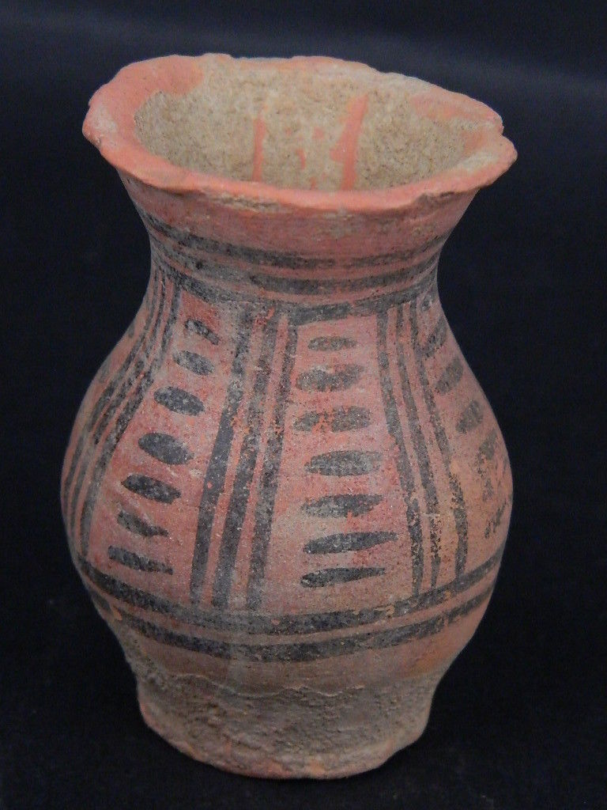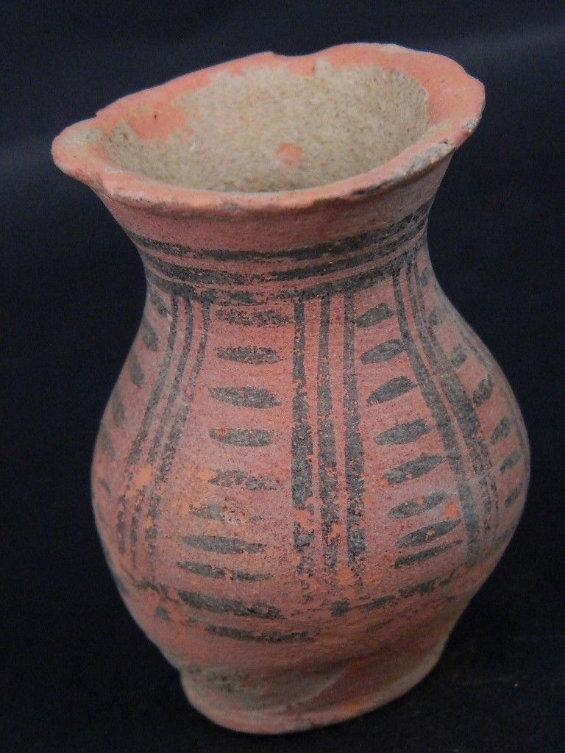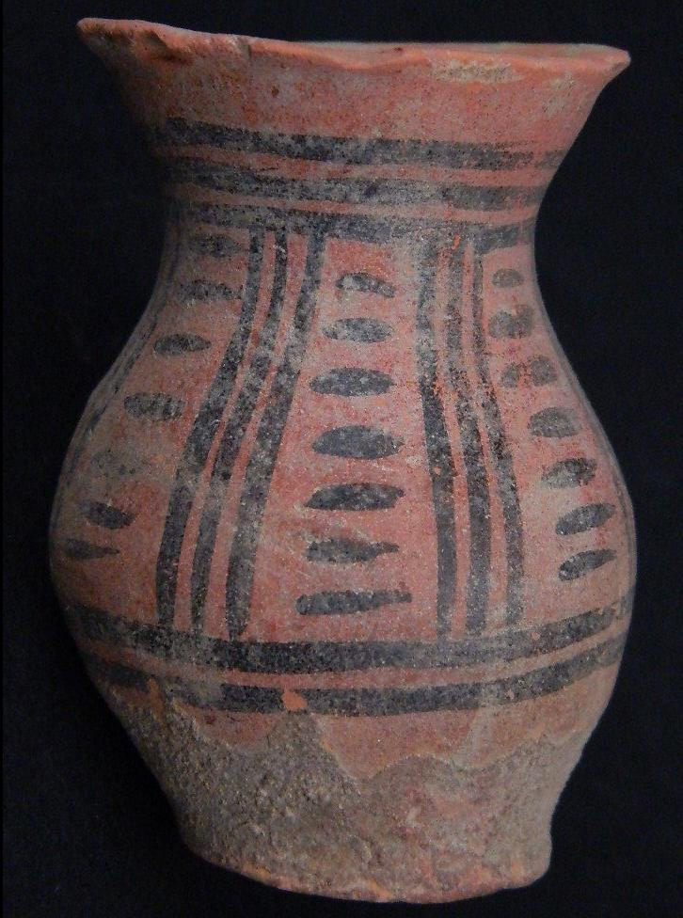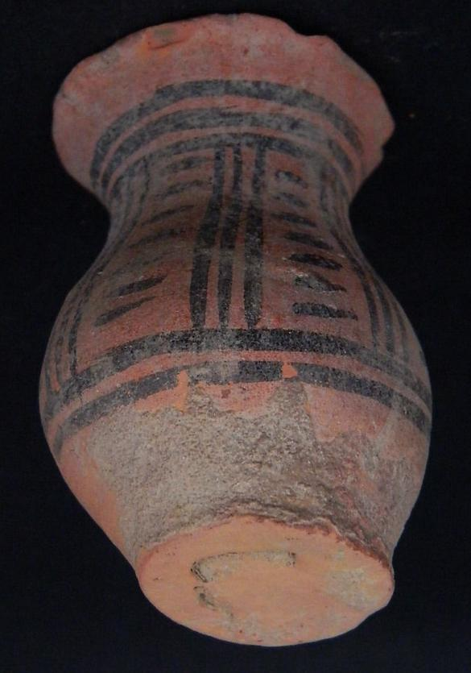

# Order details

## Sales order

Sold by [sak2014*14](http://myworld.ebay.com/sak2014*14) ( [341](http://feedback.ebay.com/ws/eBayISAPI.dll?ViewFeedback&userid=sak2014*14) )

### Delivery package 1 of 1

Estimated delivery Wednesday, Feb 3, 2016 - Tuesday, Feb 23, 2016

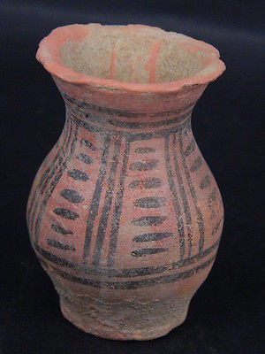

#### [Ancient Teracotta Painted Pot Indus Valley 2500 BC No Reserve #PT15082](http://www.ebay.com/itm/111872058446)

|  |  |
| --- | --- |
| Item price | $24.99 |
| Quantity | 1 |
| Item number | 111872058446 |
| Shipping service | Economy Shipping from outside US |

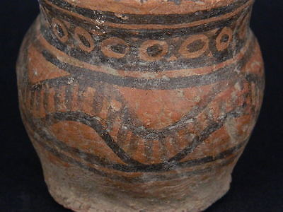

#### [Ancient Teracotta Painted Pot Indus Valley 2500 BC No Reserve #PT15083](http://www.ebay.com/itm/111872059707)

|  |  |
| --- | --- |
| Item price | $28.00 |
| Quantity | 1 |
| Item number | 111872059707 |
| Shipping service | Economy Shipping from outside US |

## Shipping address

Ralph J Coffman Jr

149 Atlantic Ave

Swampscott MA 01907-2427

United States

## Order total

|  |  |
| --- | --- |
| Subtotal | $52.99 |
| Shipping | $21.02 |

**Total**

$74.01